Edited Submission to the Heritage Council, NT in support of the Heritage listing of Kulaluk,
To
The Chair
Heritage Council, NT
PO Box 4198
Darwin NT 0801
From
adriennemcconvell@yahoo.com.au

Dear Sir,
Submission to the Heritage Council, NT in support of the Heritage listing of Kulaluk, Crown Lease in Perpetuity 671 Gwalwa Daraniki Association Inc. Lot 5182, Town of Darwin and Lot8630, Town of Nightcliff.

I write in support of the heritage listing of Kulaluk and I believe I write from a long standing, deeply held awareness and appreciation for what is embodied within its uniqueness.
Kulaluk has a great richness across the broadest spectrum of heritage values. Values it embodies are Cultural, Historical, Environmental/Natural and Social. Together, these constitute its unique identity.

I was born in Darwin and my family has been in Darwin for over 100 years, but this is a minute period of time compared to the presence of the Indigenous people of this area.
I am now a Registered Nurse, however my first degree was a BA in anthropology and prehistory/archaeology from ANU. I worked for the Northern Land Council (1978-1979) on the Kenbi Land Claim and I have a strong depth of knowledge regarding the land around Darwin and its significance to the hundreds of Larrakia and their many Indigenous neighbours including Wadjigan, Amiyangal, Menthayangal, Kiyuk, Murinpatha, Marrithiel, Kungarakany, Warai, Tiwi, Brinkin, Maranaggu and other peoples.

I knew many of the old people now gone, Larrakia and their neighbours and supporters. I have talked extensively with such key figures as Olga Singh, Bobby Secretary, Midpul (Prince of Wales), Norman Barral, Johnny Fejo, Felix Holmes, George Munggala, Fred Fogarty, Violet Adams, Nipper Rankin, Josephine Rankin, Maggie Rivers, Kitty Moffatt, Topsy Secretary. Roy Matpul, John Bianamu, Roy Burr Burr, Roy Yarrowin, Peggy Wilson, Captain Bishop to name but a few. And I know that they would be saddened to see what is happening to the country, country that was fought for by many so as to secure and it save it from destruction.

The Kulaluk Special Purpose Lease was granted in August 1979 by Paul Everingham (I attended the handover ceremony). The intention was to give the Larrakia and other Indigenous people back an area of culturally and environmentally significant land on which to live without the threat of further displacement. There was a draft plan worked out for the land use, it patently did not include carving up the country, digging up burial areas, destroying hunting and fishing areas, placing stockpiles of builders’ rubble, tar and cement and warehouses over it.
Sadly, it would seem that the area of the original SPL is being whittled away by degrees and the original intent in granting this lease is being lost.
Indeed it is clear that the proposed developments on parts of the lease compromise the original master plan that was submitted for approval before the Kulaluk lease was granted.

This divergence from the original intentions for the use of this land has been able to come about because the Gwalwa Daraniki Association (GDA) has changed its constitution, reducing the quorum needed to vote on such matters and severely limiting the number of people who can decide on the use of the land at Kulaluk. Let me be clear, it was never intended that most Larrakia people would have no rights over Kulaluk.

As the Kulaluk area was not subject to a land claim under the NT Land Rights Act 1976, but instead was granted as a lease, it meant that it was not required at the time to confirm who were all the rightful traditional owners of the land nor who were all the other Aboriginal people with an interest in the land. The result was that most Larrakia were not in the GDA and therefore not included as leaseholders.
The vast bulk of the Larrakia today have no legal rights over Kulaluk land.
For example, old lady Ababa, whose descendants include the extended Baban family, was always paying social visits to her close relatives living at Kulaluk, I often saw her there, but her family today have no rights to their ancestral land.
Captain Bishop, who mostly lived at Kulaluk was a respected elder, and has descendants alive today, they too have no rights to Kulaluk land.
Yet another example was Victor Williams, a well known and respected Larrakia man who was important for Larrakia ceremony and who went out on a limb to help secure access to the important Larrakia men’s ceremony ground ,Gundal, at Larrakeyah Army Barracks. See film and photos of this event where he and his close kinswoman, Dolly Garinyi, and others were finally allowed to visit this sacred ground after a lengthy application process.

https://www.youtube.com/watch?v=09fC_IQXPbY&feature=share

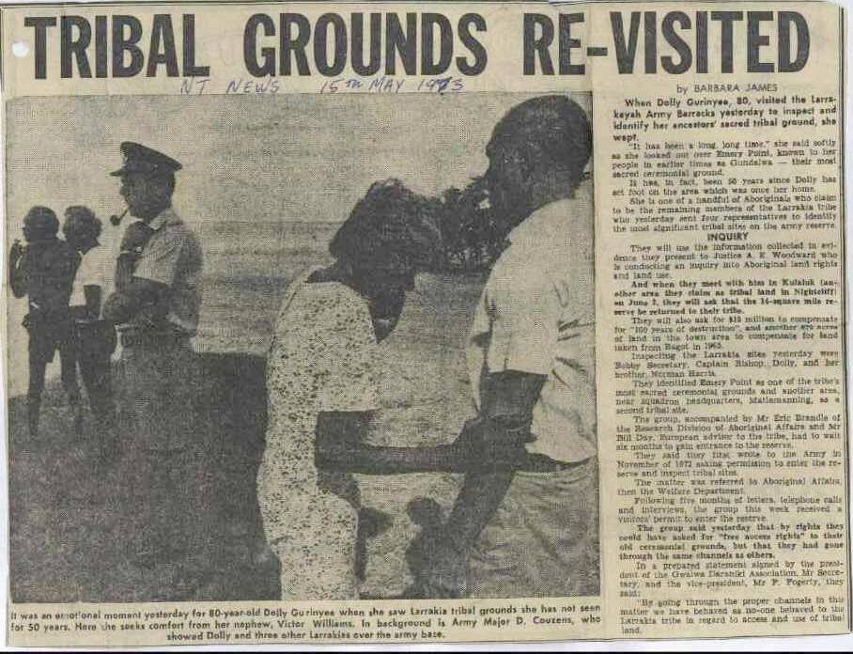
Victor Williams (pictured above supporting his aunt Dolly Garirnyi at Goondal/Gundal), a proud Larrakia man, fought for Larrakia land but his descendants have no rights over Kulaluk today.

Victor Williams, above, speaking with fellow elder Norman Baral at Gundal, Emery Point. Eric Fejo, below, a proud Larrakia man, holds the Kulaluk flag but he is unable have a say in decisions which affect the future of Kulaluk
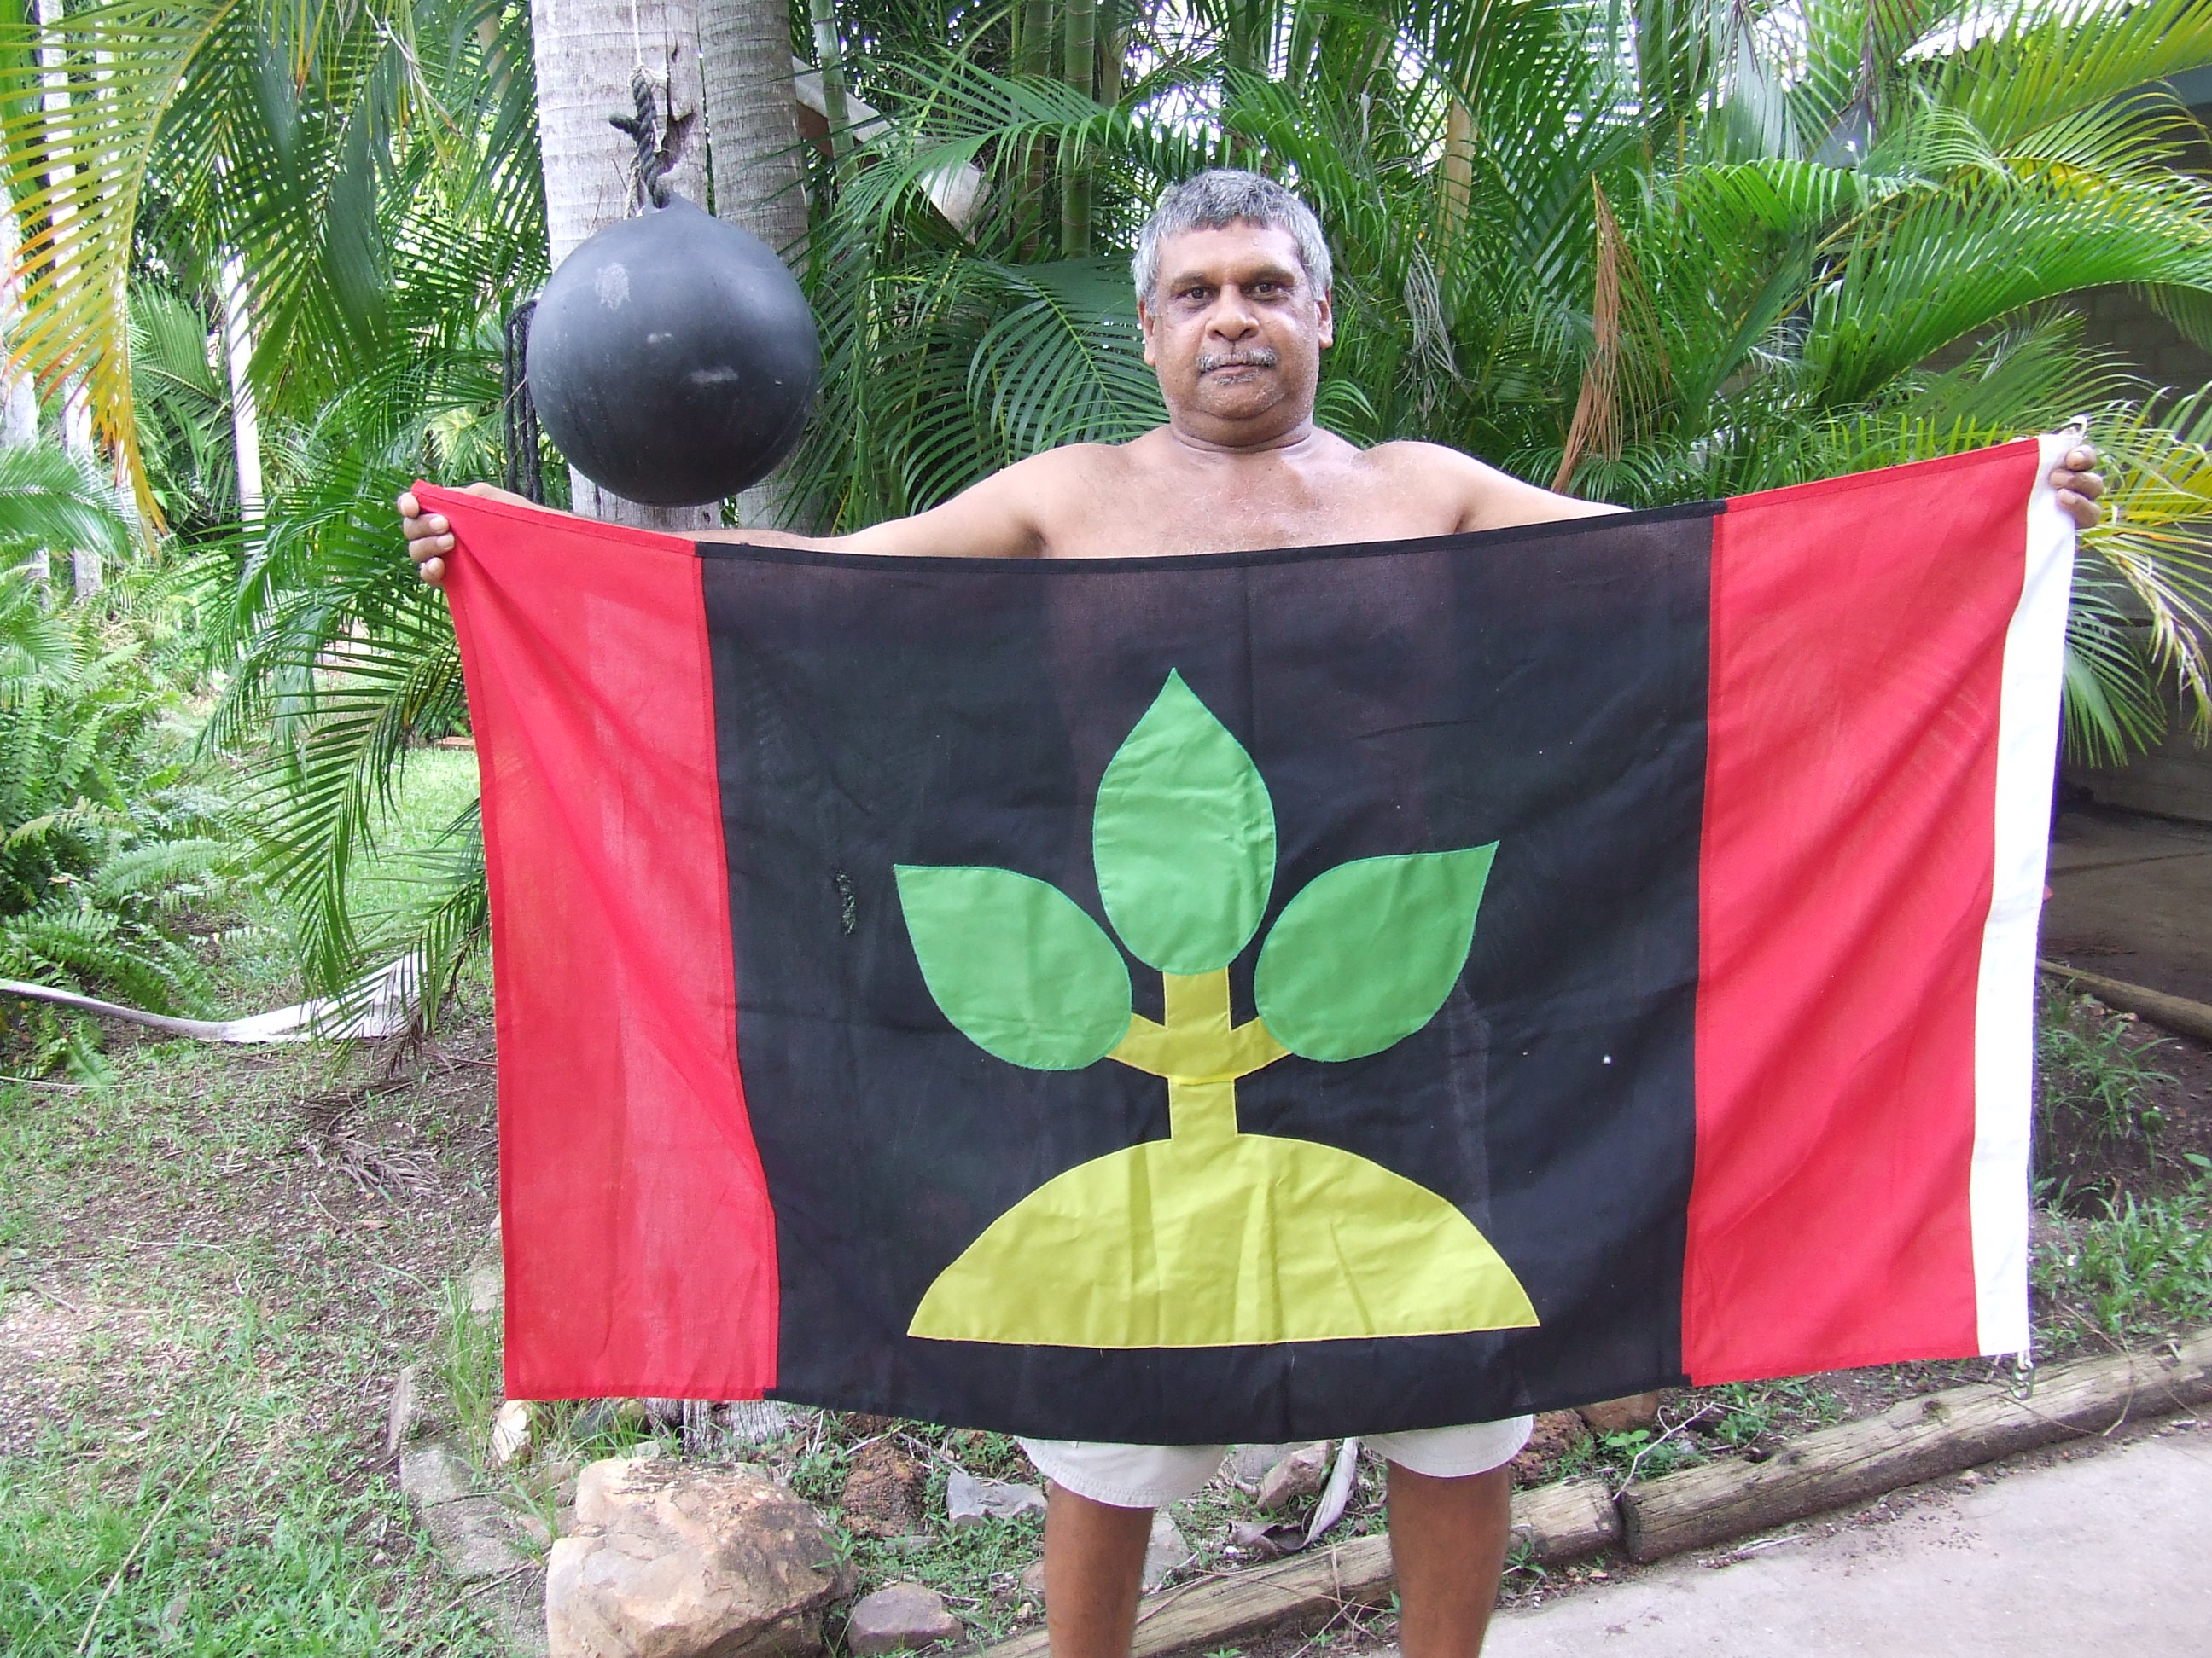

The list of Larrakia who have been dispossessed of rights to their country at Kulaluk is lengthy. See Saltwater People for more about Larrakia families.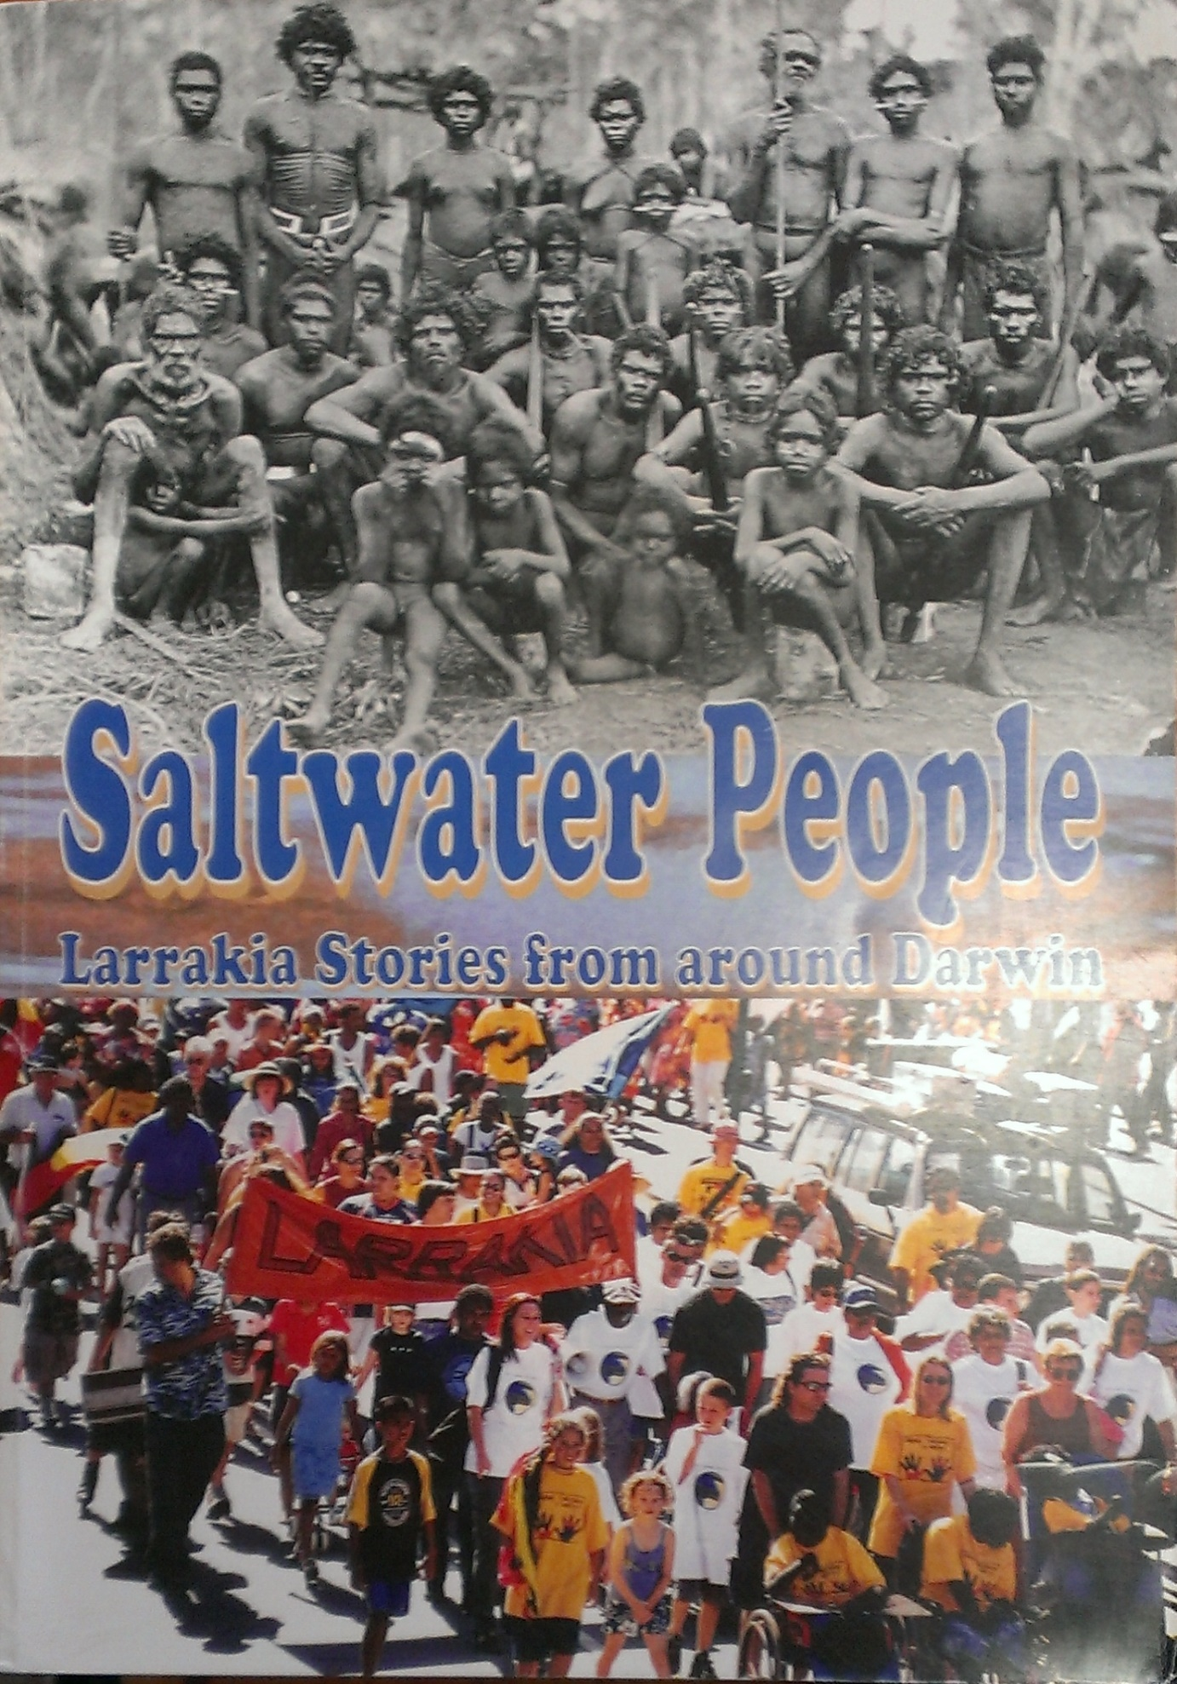

It seems wrong from an ethical, equitable and moral standpoint, that a few (unrepresentative) people can sell off the Kulaluk land, degrade it and effectively dismiss and throw away the cultural, historical, social and natural heritage of this important piece of Larrakia land. The developers would appear to have no understanding of, or respect for the heritage values of Kulaluk. As well neither do the few who make up a quorum in the Gwalwa Dariniki Association (GDA). If the few who have voting rights in the GDA had an appreciation of the heritage values of this land they would never have allowed the (illegal) dumping of builders’ rubble in the middle of Kulaluk or the clearing of land at a burial site within Kulaluk..

Cultural values of Kulaluk
Kulaluk is an important place for ceremonies for all Larrakia and for many neighbouring Australian Aboriginal groups.

In 1989 I attended a Gapuk (a post funeral smoking ceremony where the belongings of the deceased are burned) at Kulaluk for the late Mr Nipper Rankin, a Kiuk/Wadjigan man married to a Larrakia woman, Josephine Rankin.
For a short edited version of the original footage recorded by my husband, Patrick McConvell and myself at Kulaluk see
https://www.youtube.com/watch?v=waRAmYPGRXY

At this important cultural event Aboriginal people, including traditional singers, dancers and musicians came from Wadeye, Daly River, Belyuen and other communities to participate in the Gapuk for this man. They acknowledged and respected this man and the role he had played in their world. Such an occasion/event required much planning and coordination. Many lengths of fabric were purchased by hosts of people to contribute to the ritual. Ceremonial specialists, with particular relationships to the deceased had to travel from various places and arrive at an arranged date and time, all knowing their roles and functions for the event. Food was prepared and served. Close relatives of the deceased, including his wife, gathered and observed the event. When the ceremony was completed his wife was fed first. Extended family and other participants all had their roles which they fulfilled as their ancestors have done for millennia.

See below for a series of still images taken from the footage of the Kapuk for Nipper Rankin. The images show: dancers, fabrics hanging (for distribution after the Gapuk), burning of the belongings of the deceased, widow of the deceased (Larrakia lady) Josephine Rankin being the first to receive a meal after the Gapuk, Topsy Secretary sitting with other elderly ladies at the Gapuk, and Kitty Moffatt (an initiated Wadjigan/Wagaitj lady born at Anson Bay and with strong ties to the Larrakia and very knowledgeable about Larrakia land) talking to me.

Kulaluk, for recorded history and long before, is a place for ceremonies, not just for Larrakia but also for Yolngu, Tiwi, Daly River people and Western Arnhem Land people.
As noted in the Ritchie Report, Gunabibi ceremonies have been held at Kulaluk.
Many Tiwi were buried at Kulaluk and Pukamani Poles were located near the intersection of Dick Ward Drive and Totem Road (hence the name Totem Road, Tiwi burial poles look like “Totem poles”).

Kulaluk has culturally significant places such as the burial ground/cemetery ground, the Pukamani Ground & the Gunabibi ground which should not become small islands in a sea of development but which should remain part of the larger whole as intended in the original SPL. The Gunabibi ground is sacred to North East Arnhem Landers: have they been consulted on this matter? Have the Tiwi been consulted about the Pukamani Ground?
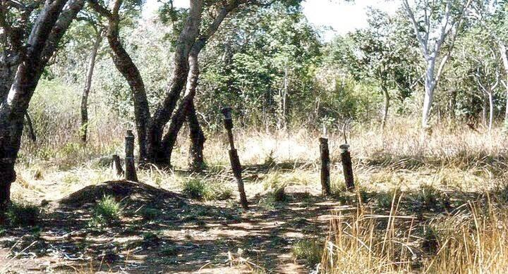
Above: an old photo of the Pukamani Poles (at the site noted on the map below) in the vicinity of Cocout Grove, in what was Bagot and now is Kulaluk. Below: this map of the Town of Nightcliff dated 1949, which marks an area of Kulaluk as a “Native Burial Ground”, is the European-Australian proof of the presence of the burial ground.

These sites are also noted in maps commissioned by the Aboriginal Areas Protection Authority (AAPA) and shown in the Krimhilde Henderson report, “Land Use Field Study Of The Kulaluk Area”, (c.1984).

“Kulaluk waterhole”, which is referred to in the HISTORY OF THE KULALUK LEASE by Krimhilde Henderson 1984 page 8, is part of the Kenbi Dreaming track. In the Dreaming story Kenbi (which means didjeridoo) is a hollow tunnel or “bamboo” underground which connects Kulaluk waterhole to the waterhole at Belyuen and to other waterholes on islands in Bynoe Harbour. The name Kenbi was chosen as the name for the Kenbi Land Claim because of the significance of this dreaming track to the Larrakia and their neighbours including the Wadjigan/Wagaitj and Kiuk.

Natural Heritage values of Kulaluk
Kulaluk has a variety of different habitats, which include: mangrove, with its rich diversity of marine and tidal plants and animals; monsoon forest, very little of which still exists in the Darwin area; tropical savannah woodland which supports many bird species including the majestic black cockatoo.
Over many years I have observed a group of Black Cockatoos living in the Kulaluk bushland which borders Fitzer Drive, Ludmilla. Darwin is fortunate to have retained such an area of bushland. Smart cities maintain areas of environmental value and don’t allow everything to be given up to tar and cement.

Migratory birds, some of which are rare, fly from Asia to visit the Kulaluk area. These include the Great Knot, the Oriental Plover and the Asian Dowitcher.

The breaking up of Kulaluk by the various development proposals will have a negative impact on the native fauna by destroying the natural corridors for wildlife between different habitats.

Indigenous people still use this land for sustainable hunting, fishing and food gathering (Krimhilde Henderson’s Kulaluk land use study supports this). The proposed changes would affect access to parts of Kulaluk by indigenous people using the land for food gathering purposes.

Drainage and run off from industry from the proposed subdivision will adversely affect the natural environment of Kulaluk. This in turn will affect Indigenous people who use this land for hunting, fishing and food gathering.

Illegal dumping of builders’ waste over the years has negatively affected a large area of Kulaluk. The rubble does a lot of environmental damage and may contain dangerous pollutants such as asbestos. The builders’ rubble should never have been placed there. This illegal dumping should result in the prosecution of those who dumped it. The rubble should be removed immediately and the land returned to its previous natural state.
The GDA has shown that they cannot and will not protect the natural environment of Kulaluk. The huge stockpile of builder’s rubble is testament to this.

The crab farm development which occurred at Kulaluk in the 1980’s was a dismal failure and its only legacy is a damaged area of mangroves.

The wider Darwin community too has an interest in Kulaluk, if not for the cultural heritage and historical heritage, then for the environmental heritage. Many people in Darwin enjoy driving or cycling along Dick Ward Drive surrounded on both sides by natural bushland. They would also enjoy access to Kulaluk, if a Visitor’s Centre were to be built, to enjoy guided walks and learn about the unique environmental Heritage values of Kulaluk.

Historical Values of Kulaluk
The struggle for land rights by the Larrakia and their supporters in the 60’s and 70’s was one of the earliest land rights campaigns in Australia, and is of importance in the history of the land rights movement and the history of Darwin. It led to a reaction from conservative politicians who pushed through some rapid amendments to the Land Rights Bill before it became the Land Rights Act 1976 One of the amendments made it impossible to claim land within a “town boundary” and saw the NT Government draw huge town boundaries around most every town in the NT, for example the small town of Borroloola, which suddenly acquired a huge town boundary.
As a result of this legislation Kulaluk could not be claimed under the Land Rights Act NT 1976, which meant it was only able to be claimed through political lobbying and civil protest. The land (Kulaluk) which the NT Government did eventually agree to give back to the Larrakia could only be handed back as a Special Purpose Lease, which means the land can easily be lost through selling on the lease to the land. The proposed breaking up of this area for commercial development runs counter to the original intentions of the people who fought to have this land returned to its traditional owners

It was originally intended that the Kulaluk Special Purpose Lease
(SPL) would protect Kulaluk’s natural environment and preserve a place of cultural importance for ongoing cultural practices.

Social & identity values of Kulaluk
Kulaluk could become a place for the Larrakia and their neighbours to express their identity through culture and history in a concrete way by developing a visitor centre, showcasing the cultural and natural aspects of Kulaluk (right in the heart of Darwin). Such a centre could conduct walking tours and have education resources for Darwin residents and interstate and international visitors. The education resources the centre could house could cover all the heritage aspects of Kulaluk, cultural, environmental historical and social This would be a positive way for the Larrakia to connect with the broader public while enhancing their own identity.
The visitor centre could be built on the area damaged by the failed crab farm and in that way would not impact on the environment of Kulaluk.

SUMMARY
Kulaluk has culturally significant places such as the burial ground/cemetery, the Pukamani Ground & the Gunabibi ground which should not become small islands in a sea of development but which should remain part of the larger whole as intended in the original SPL.

The Kulaluk Special Purpose Lease was granted in August 1979 by Paul Everingham (I attended the handover ceremony). The intention was to give the Larrakia and other indigenous people back an area of culturally and environmentally significant land to maintain without the threat of further loss and displacement. The area of the original SPL is being whittled away by degrees and the original intent in granting this lease is being lost.

Major developments on Kulaluk land would compromise the original master plan that was submitted for approval before the Kulaluk lease was granted. The very small quorum that the Gwalwa Daraniki Association (GDA) requires to pass development plans in Kulaluk is the result of the 2006 amendments to the GDA Constitution. These constitutional changes make it possible for a tiny group of people to decide on the future of Kulaluk

It seems morally reprehensible that a few people can sell off this land, degrade it and throw away the cultural, historical and natural heritage of this special piece of Larrakia land and history which is so important to the identity of so many Larrakia and non Larrakia in Darwin. Kulaluk is a place which enriches the lives of many and which can enrich the lives of many more in the future.

The developers would appear to have little or no respect for the heritage values of Kulaluk and neither do the few who make up the quorum in the Gwalwa Dariniki. If they did have respect for Kulaluk they would never have allowed the (illegal) dumping of the builders’ rubble on a huge scale in the middle of Kulaluk.

The wider Darwin community too has an interest in Kulaluk, not only for the cultural and historical heritage it represents, but for the urgency of environmental heritage issues.

Great cities are marked not only by their new developments but by what they retain. Darwin has a unique heritage, a heritage to be celebrated and built upon rather than airbrushed out of existence.
Hoping you will give consideration to these issues.

Yours Sincerely

Adrienne McConvell

